|  |  |  |
| --- | --- | --- |
| **Problem Chosen** E | **2022 MCM/ICM Summary Sheet** | **Team Control Number** 2213398 |

**Harvest or not? Let’s decide scientifically!**

Forests can control atmospheric carbon levels in many ways thus people need to utilize and manage forests well, especially faced with today's global warming threat. Since a one-size-fits-all approach clearly cannot maximize the value of diverse forests, it’s an essential issue for us to know how to obtain the carbon sequestration potential of a particular forest object and then formulate targeted optimal guidance comprehensively and scientifically.

First, we establish **Carbon Sequestration Model** to obtain the total result of carbon sequestration. Considering influencing factors, this model includes **two core formulas** -- "carbon sequestration amount - tree age formula" and "optimal number of trees of each age - tree age formula". The final result balances the two carbon storage methods of forest products and forest retention thus determines the most effective way at carbon sequestration.

Next, considering that the value of forests is not only carbon sequestration, we begin with **improving the spectrum** for the improvement of forest management plan, adding "potential carbon sequestration, conservation and biodiversity aspects, recreational uses, and cultural considerations". At the same time, we **determine the corresponding conditions** that ",,,,, trees should be uncut".

After clarifying the scope and harvest conditions, we made **Forest Management Decision Model**. It integrates various forest values and thus leads to a more comprehensive optimal plan for forest management. It is worth noting that there is always **a transition point** when the two management plans are implemented, and we find that generally this transition point can be effectively determined by the ",,," parameters of the forest.

Then, we apply the above two models to various forests, including **",,,, selected forest name"**.完全不砍100年的总固定量是、、、，整体发展得分是、、、。三种砍树情况下的总固定量及发展得分分别是、、、。我们在后三种情况下继续优化，从而确保了合理性且是最佳的 thus verify the rationality of our plan. Our conclusion is:将什么类型的树木或者什么年龄的树木砍掉或者最终保持到什么样的状态，比保持不刊更有利于这个森林整理发展. 在砍树政策实施的条件下，将最有利于、、、森林的整理发展，且多少含量的 carbon would be sequestered by the forest and its products over 100 years, which is (是不实行的多少倍) total amount without harvest.

In addition, to ensure a smooth transition from the existing management schedule to the new one, we not only discuss **a targeted strategy** that is relevant to anyone related, but also write a two-page **non-technical newspaper article** to convince the local community.

Finally, we carry out **a sensitivity analysis of the \\\ model** and **an error analysis of the \\\\ model**, demonstrating the robustness and accuracy of our models. We also evaluate the advantages and disadvantages of our models, hoping to continue to extend them in the future.

**Keywords:** Forest Management; Sustainable Development; Carbon Sequestration Model; Forest Management Decision Model; ……. Forest

Table of Contents

1 Introduction 3

1.1 Problem Background 3

1.2 Restatement of the Problem 3

1.3 Our Work(要添加校对) 4

2 Assumptions and Justifications 5

3 Notations and Deﬁnitions 5

3.1 Notations 5

3.2 Definitions 6

4 Carbon Sequestration Model 6

4.1 Carbon Sequestration Calculation Model 6

4.1.1 Curve A: Tree Age - Storage CO2 Curve Based on Volume-Biomass Method 6

4.1.2 Curve B: Tree Age - Covered Area Curve 7

4.1.3 Specific Calculation of Carbon Sequestration 7

4.2 Forest Dynamic Development Model 8

4.2.1 Without Harvesting 8

4.2.2 With Harvesting 9

4.3 Forest Management Decision Model for Carbon Sequestration 9

5 The name of model 3 10

6 Sensitivity Analysis 10

7 Model Evaluation 11

7.1 Strengths 11

7.2 Weaknesses 12

References 12

Appendices 14

# Introduction

## Problem Background

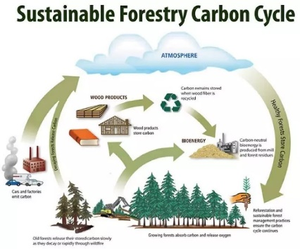*“Nature is a loving mother, but also a butcher in cold blood”,* Victor Hugo once said. At present, global warming has become a massive threat faced by countries all around the world. In order to control atmospheric temperature, promote sustainable economic and ecological development, people need to take effective measures to reduce greenhouse gases in the atmosphere. It is not only related to reducing emissions, but can also be achieved by enhancing carbon sequestration.

Due to the natural photosynthesis of green plants, it can be used for carbon sequestration. It is an effective, environmentally friendly and economical way. Therefore, how much carbon dioxide forests and their products can be expected to sequester over time is the primary issue in determining how to manage forests well. At the same time, because forests are not only for carbon storage, people must also find a balance between the other values of forests and the value of carbon sequestration. Considering the various values of forests will not only provide best solutions for forest managers, but also provide correct directions for our greener and more environmentally-friendly future.

## Restatement of the Problem

Forests, and the products they produce, are crucial to repairing our world’s climate and creating a low carbon future. Given the background information and constraints identified in the problem statement, we need to solve the following problems:

* Establish a carbon sequestration calculation model to determine the total amount of carbon dioxide that can be sequestered by forests and their products, and then determine how to balance harvesting values and sequestering values as living trees for a most effective carbon sequestration plan.
* Develop a decision-making model for a comprehensive forest management plan. It is necessary to clarify the management scope of the decision-making model, consider the situation that the forest should not be cut down, figure whether there is a transition point between the implementation of the two management plans and how to determine the point, based on the characteristics or location of the forest.
* Apply the model to a variety of forests and identify a forest that would suggest the inclusion of harvesting in its management plan. It needs to indicate how much carbon dioxide the forest and its products would sequester over a 100-year period, and justify the decision-making model to develop a forest management plan.
* Supposing that best management plan logging intervals that are 10 years longer than current practices. Discuss a strategy that is relevant to forest managers and all who use the forest to convert the existing schedule to the new one.
* Write a one- to two-page non-technical newspaper article to explain the rationale of the proposed forest management plan given by the models. The explanation should be clear and explicit enough to convince the local community that this is the best decision for them.

## Our Work(要添加校对)

1. We develop a carbon sequestration model to obtain the total result of carbon sequestration. Considering influencing factors, this model includes two core formulas -- "carbon sequestration amount-tree age formula" and "optimal number of trees of each age-tree age formula". The result balances the two carbon storage methods of forest products and forest retention, and can determines what forest management plan is most effective at sequestering carbon dioxide.
2. Considering that the value of forests is not only carbon sequestration, we improve the spectrum for the improvement of forest management plan, adding "potential carbon sequestration, conservation and biodiversity aspects, recreational uses, and cultural considerations". At the same time, we determine the corresponding conditions that ",,,,, trees should be uncut".
3. We make a decision model after clarifying the scope and harvest conditions. This model integrates various forest values and thus leads to a more comprehensive optimal plan for forest management. It is worth noting that there is always a transition point when the two management plans are implemented, and we find that generally this transition point can be effectively determined by the ",,,,,," parameters of the forest.
4. We apply the above two models to various forests to obtain their corresponding recommended management plans. Based on our models, the future management of ",,,, selected forest name" should be harvested to produce a product. We calculate its total carbon sequestration amount of the forest and its products over 100 years. Compared with the total amount without harvesting trees, we thus verify the rationality of our plan.
5. We also discuss a strategy that is relevant to forest managers and all who use the forest to achieve a good transition from the existing management schedule to the new one. Based on the assumptions given, the best management plan's logging interval is 10 years longer than current management practices.
6. We write a two-page non-technical newspaper article to justify our analysis to convince the local community that harvesting would be more beneficial for carbon sequestration and a long-term development.

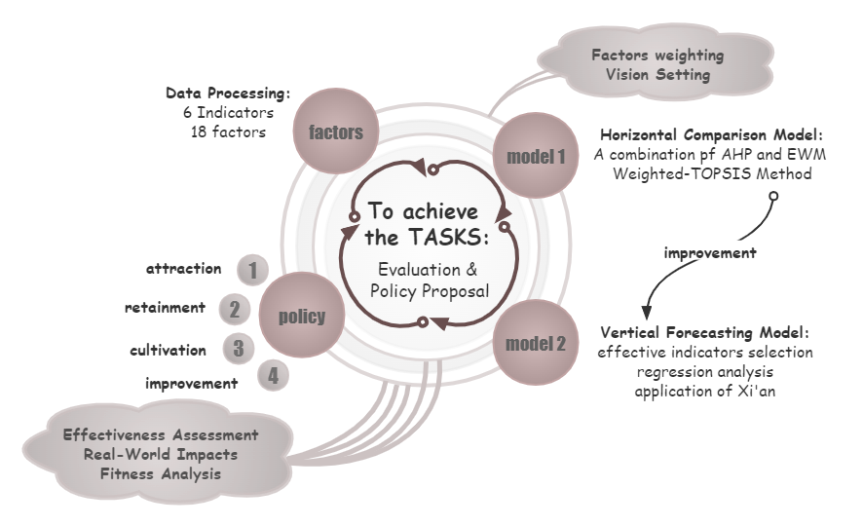

# Assumptions and Justifications

* **Deforestation is made into long-term products that more carbon can be sequestered than existing practices, rather than products that used quickly.**

Since we are advising forest managers, we do not consider too many economic and commercial considerations.

* **The ways of harvesting do not bring about extra carbon release.**

Logging operations are related to various uncertainties such as means of transportation, logging techniques, logging time and so on, which are difficult to take into account. Also, in the process of harvesting or transportation, the carbon dioxide emissions are far less than the carbon sequestration in wood. Therefore, it can be ignored in our analysis.

* **The carbon release from fossil energy retained in the soil after tree felling is not considered in the model.**

Carbon sequestration occurs in above-ground biomass and below-ground soils, and felling trees releases carbon into soils. They should have been considered in continuous biomass production, but we do not take account of them in our calculations for analysis simplification.

# Notations and Deﬁnitions

## Notations

The key mathematical notations used in this paper are listed in Table 1.

Table 1: Notations used in this paper

|  |  |  |
| --- | --- | --- |
| **Symbol** | **Description** | **Unit** |
|  |  |  |

## Definitions

* **Harvesting (trees):** the process of cutting down trees to be used as forest products.
* **Forest Management:** the process of managing a forest to include determining what trees should be cut down, which trees should be left standing, a timeline for harvesting the trees, and how to regenerate the forest.

# Carbon Sequestration Model

The first task is to determine the amount of carbon dioxide sequestered by forests and their wood products over a period of time, and to formulate appropriate forest management policies to maximize the carbon dioxide sequestration capacity of forests. In order to meet the requirements, the very beginning task is to establish a reasonable static carbon dioxide storage capacity calculation model, and then obtain the specific capacity of the forest to absorb carbon dioxide through several static data of the forest. But in fact, the forest is a dynamic system, which continue to grow. Similar to human society, there is a situation of birth and old replacement.

Only using a single static computing model cannot meet the computing needs in a long period of time. Therefore, a developmental model for measuring the growth and replacement of trees of different ages in the forest is also crucial, which can provide a discrete static situation during the dynamic development of the forest. In addition, in order to fully utilize their carbon dioxide sequestration capacity, a planning model is needed to determine more effective forest management options.

Corresponding to the above requirements, the carbon sequestration model should consist of the following three sub-models:

1. Calculation models for quantifying carbon dioxide sequestration in forests and their wood products;

2. A development model that is used to predict the development of forests over time, and each tree age contains specific values ​​of biomass;

3. A planning model for determining optimal CO2 storage management policies through linear programming.

## Carbon Sequestration Calculation Model

To make it easier to understand and calculate the total amount of carbon dioxide sequestered, we develop two curves related to tree age. **Curve A** represents the relationship between the age of one particular tree and its ability to sequester carbon dioxide. **Curve B** shows the coverage areas of trees of different ages in the forest studied. The specific meanings of these two curves will be introduced separately below, and the method of calculating forest carbon dioxide sequestration will be determined accordingly.

### Curve A: Tree Age - Storage CO2 Curve Based on Volume-Biomass Method

* **Carbon Fixation by Forests**

There are many methods for the calculation of forest carbon sequestration. We mainly base on **the volume-biomass method** for calculation. when the tree age is $t$, we define $V(t)$ represents the stock volume per unit area $(m^3/hm^2)$, and $B(t)$ represets the biomass per unit area $(t/hm^2).$ For most forest species, there is a linear relationship between $B(t)$ and $V(t)$ [Document], which is shown in formula (1):

|  |  |
| --- | --- |
| $$B(t)=aV(t)+b$$ | () |

The relationship between the fixed amount of carbon dioxide per unit area of forest $M(t) (tC/hm^2)$ and the biomass per unit area is shown in formula (2):

|  |  |
| --- | --- |
| $$M(t)=0.5×3.67×B(t)$$ | () |

where $0.5$ is the biological carbon content rate, and $3.67$ is the conversion factor related to carbon dioxide and carbon.

So far, we can obtain the relationship between the carbon sequestration per unit area of forest and the storage amount through biomass.

The accumulation volume per unit area $V(t)$ and tree age have the characteristics of a general growth curve, so we can use **Richards Curve** fitting [ref]. The curve equation is shown in formula (3):

|  |  |
| --- | --- |
| $$V(t)=A{(1−Be^{−Kt})}^{\frac{1}{1−m}}$$ | () |

where $A, B, K,$ and $m$ are all parameters with specific biological significance.

By derivation of Richards curve, the relationship curve $dM(t)$ of tree carbon dioxide absorption rate $dM$ and tree age can be obtained.

* **Carbon Fixation by Forest Products**

Since forest products do not have a biomass-stock volume curve, we directly use the volume to calculate their carbon dioxide fixation per unit area $(t/hm^2),$ as shown in equation (4):

|  |  |
| --- | --- |
| $$c(t)=0.5×3.67×ρ×V(t)×TR$$ | () |

where 0.5 is the biological carbon content rate, 3.67 is the conversion factor of carbon dioxide and carbon, \rho is the average density of forest trees, and TR is the mining yield, which is 55%. [literature]

### Curve B: Tree Age - Covered Area Curve

In a specific forest, for any specific tree, there is a specific "tree age-covered area curve". We represent this with an equation $X(t)$, which means the area $(hm^2)$ covered by a particular tree of age $t$ in that forest.

However, in practice, it is difficult to accurately measure the tree age of trees and make statistics on their coverage area, so the statistics of coverage area are often given for individuals with a certain tree age interval. In this regard, we choose to use the least squares method to fit the limited data points, and consider the fitted curve to be the curve B we want.

### Specific Calculation of Carbon Sequestration

When calculating the specific amount of carbon dioxide sequestration, according to the assumptions in this paper, we all use the discrete point data obtained from curves A and B.

Let $T_{j}(t)$ represent the carbon dioxide absorption $(tC)$ of the tree with age $t$ in the $j$ th year, then there is a relationship as shown in Equation (5):

|  |  |
| --- | --- |
| $$T_{j}(t)={dM}_{j}(t)×X_{j}(t)$$ | (5) |

We consider that the total amount of carbon dioxide absorbed by trees in one year is the sum of the amount absorbed by trees of all tree ages, from which the expression of the total amount of carbon dioxide absorbed by trees in the $j$ th year, $T_{j}$ equation can be obtained, as shown in Equation (6):

|  |  |
| --- | --- |
| $$T_{j}=\sum_{i=0}^{tmax}{T_{j}(i)},i=0,1,2,...,tmax$$ | (6) |

Let $T$ be the total amount of carbon dioxide absorbed by trees in the first $k$ years, then the expression of $T$ is shown in Equation (7):

|  |  |
| --- | --- |
| $$T=\sum_{j=0}^{k}{T_{j}},j=0,1,2,...,k$$ | (7) |

In addition to this, we believe that wood products made from felled trees have some capacity to store carbon dioxide, but each type of wood product corrodes at a constant rate each year, gradually releasing its stored carbon dioxide.

Let $P$ be the total amount of carbon dioxide stored in wood products in year k, $C_{j}$ be the total amount of carbon dioxide contained in trees felled in year. $ω_{1}$ and $ω_{2}$ are the proportions of wood pulp and wood in felled trees respectively ($ω_{1}+ω_{2}=1$), $α_{1}$ and $α_{2}$ are the corrosion rates of wood pulp and wood, respectively, then there is a relationship as shown in formula (8):

|  |  |
| --- | --- |
| $$P=\sum_{j=0}^{k}{C_{j}×\left[ω_{1}{(1−α_{1})}^{k−j}+ω_{2}{(1−α_{2})}^{k−j}\right]},j=0,1,2,...,k$$ | (8) |

From this, it can be seen that the expression of the total carbon dioxide sequestration amount $S$ in the first k years is shown in Equation (9):

|  |  |
| --- | --- |
| $$S=T+P$$ | (9) |

## Forest Dynamic Development Model

### Without Harvesting

We define $X(t,k)$ as the corresponding coverage area $(hm^2)$ of the trees whose age is $t$ and $k$ years from the initial year in the forest. The upper limit of the lifespan of the trees is $tmax$, then $X(t,k)={\left[\begin{matrix}X(0,k) & X(1,k) & ... & X(tmax,k)\end{matrix}\right]}^{T}$ is the coverage of the trees of each age matrix of the kth year area matrix.

Since the environmental capacity of the forest is certain, in order to maximize the ability of the forest to absorb carbon dioxide, it is considered that there is no vacant capacity in the forest, that is, if a tree naturally dies, new trees will be immediately planted to fill the vacancy. Therefore, in the case of ignoring artificial tree cutting and artificial planting of new trees, there is a relationship as shown in formula (10):

|  |  |
| --- | --- |
| $$\left\{\begin{aligned}X(0,k+1)=X(tmax,k) \\ X(1,k+1)=X(0,k) \\ ⋮ \\ X(tmax,k+1)=X(tmax−1,k)\end{aligned}\right.$$ | (10) |

Its matrix form is shown in formula (11):

|  |  |
| --- | --- |
| $$\left[\begin{matrix}X(0,k+1) \\ X(1,k+1) \\ ⋮ \\ X(tmax,k+1)\end{matrix}\right]=\left[\begin{matrix}0 & 0 & ⋯ & 0 & 1 \\ 1 & 0 & … & 0 & 0 \\ ⋮ & ⋮ & ⋱ & ⋮ & ⋮ \\ 0 & 0 & ⋯ & 0 & 0 \\ 0 & 0 & ⋯ & 1 & 0\end{matrix}\right]\left[\begin{matrix}X(0,k) \\ X(1,k) \\ ⋮ \\ X(tmax,k)\end{matrix}\right]⇔X(t,k+1)=G∙X(t,k)$$ | (11) |

where $G$ is defined as the growth matrix.

### With Harvesting

Wood products can store carbon dioxide to a certain extent. However, after the natural death of trees, it is believed that they will release the stored carbon dioxide immediately. Therefore, in order to increase the carbon dioxide storage capacity, all trees that have reached the upper limit of their lifespan will be cut down.

We define $c=diag(p_{k},1−c(1,k),1−c(2,k),...,1−c(tmax,k))$ as the cutting matrix, where $p_{k}$ represents the first The ratio of the area of saplings that should be replanted at the end of year $k$ to $X(0,k)$, where $c(i,k)$ represents the felling rate of trees with age $i$ in the $k$ th year. Thus, the expression of $X(t,k)$ after deforestation in the kth year can be obtained, as shown in formula (12):

|  |  |
| --- | --- |
| $$\left[\begin{matrix}X'(0,k) \\ X'(1,k) \\ ⋮ \\ X'(tmax,k)\end{matrix}\right]=\left[\begin{matrix}p_{k} & 0 & ⋯ & 0 \\ 0 & 1−c(1,k) & … & 0 \\ ⋮ & ⋮ & ⋱ & ⋮ \\ 0 & 0 & … & 1−c(tmax,k)\end{matrix}\right]\left[\begin{matrix}X(0,k) \\ X(1,k) \\ ⋮ \\ X(tmax,k)\end{matrix}\right]$$ | (12) |

Considering the natural growth and felling of trees, the completed recursive process is obtained, as shown in Equation (13):

|  |  |
| --- | --- |
| $$X(t,k+1)=G∙c∙X(t,k)$$ | (13) |

## Forest Management Decision Model for Carbon Sequestration

* **Decision Indicator:** Harvest Matrix $c$

Since the model has only one target - the amount of carbon dioxide sequestration. It is only necessary to find the most critical influencing factors and optimize them to obtain a more effective management plan. In the carbon dioxide sequestration calculation model, $X(t)$ will directly affect the final value, and the X(t) of each year will be directly affected by the deforestation matrix $c$, so the deforestation matrix $c$ will be directly affected in the planning model. $c$ is set as the decision variable.

* **Objective Function:** Maximum Carbon Sequestration Amount with Tree "Potential" $T_{j}'$

If the objective function is set from a greedy point of view based on the current model, $T_{j}$ in equation (2) can be directly used as the objective function, that is, the total amount of carbon dioxide absorbed by trees in each year is maximized. But in fact, if the time interval for calculating the total carbon dioxide sequestration in forests is large enough, the total amount of carbon dioxide sequestered by newly planted trees is always greater than that of over-mature trees. Therefore, considering the "potential" of the tree, we make a certain correction to $T_{j}$ and obtain a new function $T_{j}'$. The modified objective function $T_{j}'$ prime is shown in formula (14):

|  |  |
| --- | --- |
| $$max \left\{T_{j}=\sum_{i=0}^{tmax}{{[V}_{j}(i)×\sum_{m=i}^{i+pot}{X_{j}(m)}}]\right\},\left\{\begin{aligned}i=0,1,2,...,tmax \\ m=i,i+1,i+2,...,pot\end{aligned}\right.$$ | (14) |

* **Restrictions**

In this model, the above assumption that the total area covered by trees in any year is equal to the maximum capacity of the forest needs to be satisfied. In addition, based on practical factors, the logging rate $c(i,k)$ should be between 0-1, and the planting ratio $p_{k}$ should be greater than 1, namely:

|  |  |
| --- | --- |
| $$\left\{\begin{aligned}p_{k}∙X(tmax,k)+\sum_{i=1}^{tmax}{(1−c(i,k))∙X(i,k)}=K \\ 0≤c(i,k)≤1 \\ p_{k}>1\end{aligned}\right.$$ | (15) |

# Forest Management Decision Model

We established the FDC Model for planning forest management options with the goal of maximizing CO2 sequestration. But obviously, because the goal of the above model is just one-sided, it does not have the ability to assess the overall value of a forest. In this regard, based on the classic **Hartman model**, we construct an objective function that can more comprehensively evaluate the various value of forests and give the value of forest managing optimal decision.

In addition, after trying several sets of data, we found that the management scheme proposed by the FDC Model has obvious periodicity. To be specific, after a sufficient time interval, the optimal solution always come to rotating the forest and all trees are harvested at the same time. Therefore, we made appropriate modifications to the Forest Development Model. We use forest replacement without "harvesting", plant all trees at the same time, allow them to grow naturally for one rotation period $T$ and harvest all trees at the same time.

Compared with the strategy of dynamically arranging harvesting plans every year in the FDC Model, this improved model significantly reduces labor costs, which is obviously more practical. Based on this modification, we changed the decision variable from the felling matrix $c$ to the rotation period $T$.

## Evaluation Model Based on Classic Hartman Model

In the classic Hartman model, the value of the forest is mainly divided into two categories: $G(t)$ is the stumpage value of trees of age $t$ in the forest, and $F(t)$ is the amenity value of trees of age $t$ in the forest.

$G(t)$ mainly represents the economic value of the wood produced by forest trees, which is a value that people can easily recognize intuitively in the traditional sense. Normally, $G(t)$ increases monotonically when $t$ is small. However, its growth rate keeps decreasing until it reaches a maximum value and then the growth rate drops to 0. It then decreases with the increase of $t$ until the tree enters a mature state and to be stable.

$F(t)$ mainly represents the relatively invisible value brought by the existence of upright trees in the forest, including recreation, carbon fixation, oxygen release and so on. It is generally believed that $F(t)$ keeps increasing as $t$ increases since older trees tend to have higher ecological and ornamental values ​​than younger trees.

After considering the discount rate, Hartman only gives the calculation formula considering the forest value $Val(t)$ in one rotation cycle, as shown in Equation (15):

|  |  |
| --- | --- |
| $$Val(t)=G(t)e^{−rt}+\int_{0}^{t}{e^{−rx}F(t)dx}$$ | (15) |

where $r$ is the discount rate and $t$ is the length of the rotation period.

Based on this situation, if multiple rotations are considered and the period of each rotation remains unchanged, the forest value can be expressed as:

|  |  |
| --- | --- |
| $$LEV(t)=G(t)[e^{−rt}+e^{−2rt}+e^{−3rt}+…]+\int_{0}^{t}{e^{−rx}F\left(t\right)dx\left[e^{−rt}+e^{−2rt}+e^{−3rt}+…\right]}$$ $$=\frac{G(t)e^{−rt}+\int_{0}^{t}{e^{−rx}F(t)dx}}{1−e^{−rt}}$$ | (16) |

wher $e LEV$ is the land expected value.

Therefore, we set $LEV(t)$ as the objective function, and when $LEV(t)$ reaches the maximum value, the corresponding t is the optimal rotation period length.

## The composition and specific evaluation of indicators

The classic Hartman model is concise by condensing the forest value into $F(t)$ and $G(t).$ However, since Hartman does not directly define the expressions of them, previous Hartman model cannot directly solve practical problems.

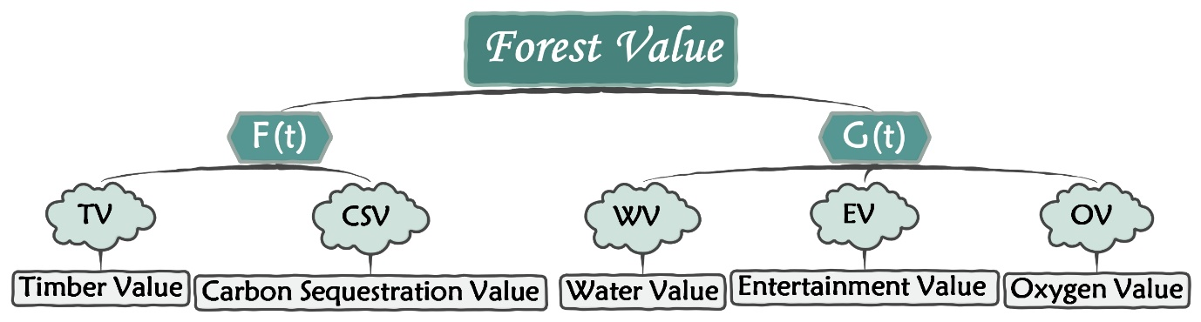

From our perspective, $F(t)$ and $G(t)$ are(恰恰是！！) the most creative parts of the classic Hartman model. Everyone can define them by themselves according to the research direction they focus on subjectively. In this regard, we refer to different focus directions of many scholars and their specific elaborations on these two indicators. We finally determine **five specific indicators** that can comprehensively assess forest value, and the sum of related fields of these indicators is the spectrum of our model.

### Evaluation indicators of $G(t)$

* **Timber Value (*TV*)**

The production value of wood is the most traditional and direct indicator of standing wood value. As an economic product, wood can be directly sold and valued. The specific calculation method of $TV$ is as follows:

$$TV=V(t)×S×TR×Pr$$

where $V(t)$ is the stock volume per unit area, $S$ is the total forest area $(hm^2)$, $TR$ is the mining yield rate, and $Pr$ is the net profit per unit volume of wood.

* **Carbon Sequestration Value ($CSV$)**

Carbon sequestration value is a newly added indicator in recent years, and its importance is increasing day by day. The surging demand for carbon dioxide emission reduction in modern society, the huge differences in emission reduction space and cost between regions have prompted the emergence of carbon trading markets. Referring to the respective carbon prices in different regions, we quantify and calculate them based on the forest carbon sequestration amount obtained by using the Richards curve mentioned above. The specific calculation method of $CSV$ is as follows:

$$CSV=c(t)×S×Pc$$

where $c(t)$ is the carbon sequestration per unit area, and $Pc$ is the local carbon price.

### Evaluation indicators of $F(t)$

* **Water Value ($WV$)**

In fact, this kind of value conclude both water and soil conservation. The influencing factors of this indicator are relatively complex, which are mainly related to the longitude $Lo(°)$, latitude $La(°)$, the annual average precipitation $Rain(mm)$, the annual average wind speed $Wind(m/s)$, the average altitude $Al(m)$, and the accumulation amount $V(t)$. Through regression analysis, we can get an empirical formula [ref]:

$$WV=116.599−0.0629Lo−1.4154La−0.0203Al−0.0004Rain−9.8838Wind−0.0008V(t)×S$$

* **Entertainment Value ($EV$)**

Entertainment value is an important part of invisible forest value, and recreational activities can include tourism, leisure hunting, etc. At present, forests mainly open to tourists have relatively mature management systems, so their recreational value can be estimated through statistical data of tourism and leisure services. The specific calculation method of $EV$ is as follows:

$$EV=EP×V(t)×S$$

where $EP$ is the output value of forest tourism and leisure services per unit volume.

* **Oxygen Value ($OV$)**

This value is mainly because of carbon fixation and oxygen release. At present, there is no unified definition of forest ecological value in academic circles. But in reality, our model does not focus on precisely assessing the ecological value of forests, but only on taking them into account. Therefore, we chose relatively important value of carbon fixation and oxygen release in the ecological value as one of the indicators of $F(t)$. The specific calculation method of WV is as follows:

$$WV=S×M(t)×Pc+S×R(t)×Po$$

where $M(t)$ is the amount of carbon dioxide absorbed per unit area $(t/hm^2)$, $R(t)$ is the amount of oxygen released per unit area, and Pc and Po are the carbon and oxygen values $(dollar/ton)$ ​​, respectively.

Through the accumulation amount, we express all these quantified indicators as a function of tree age. The optimal rotation period $t$ can finally be solved through the objective function based on our modification of Hartman's theory.

## Different Possible Results of FD Model

### Three possible results of one rotation

From the above analysis of Hartman model, when the forest value $Val(t)$ in a single rotation period reaches the maximum value, the corresponding rotation period $t$ is the optimal rotation period. We analyze the conditions under which $Val(t)$ achieves the maximum.

Since $Val(t)$ is continuous and smooth, it takes the maximum value at the point where the first derivative is equal to 0 and the second derivative is less than 0. The maximum point satisfies the conditions as shown in equation (17):

|  |  |
| --- | --- |
| $$\left\{\begin{aligned}F(t)+G'(t)=rG(t) \\ F'(t)+G''(t)<rG'(t)\end{aligned}\right.$$ | (17) |

From a geometrical point of view, only when the $F(t)+G'(t)$ $curve$ intersects the $rG(t) curve$ from above, the intersection point $t^{∗}$ is the rotation and $Val(t)$ achieves the maximum value cycle.

When the magnitude of $F(t)$ changes, as $F(t)/G(t)$ increases, there are three possible results in the optimal rotation period $t^{∗}$

Picture

**Figure 1** corresponds to the case where $F(t)/G(t)$ is small. Under this situation, there are two intersection points between the $F(t)+G\backslash prime(t) curve$ and the $rG(t) curve$. However, it only completely satisfies the condition of $formula (17)$ when the intersection on the left, and the abscissa of the left intersection point is the optimal period $t^{∗}$ we want to obtain. In this case, $G(t)$ plays a leading role in determining the optimal rotation period, and $t^{∗}$ is in the rising phase of the $G(t)$ curve.

**Figure 2** corresponds to the case where $F(t)/G(t)$ is slightly larger. At this time, there are still two intersections, and the left intersection still satisfies the condition of equation (17), so the abscissa of the left intersection is $t^{∗}$. In this case, since the magnitude of $F(t)$ increases, the optimal rotation period $t^{∗}$ is at the stage of falling $G(t)$ curve, which is $F(t)$ and $G(t)$ as a result of mutual checks and balances.

**Figure 3** corresponds to the case where $F(t)/G(t)$ is sufficiently large. At this time, the $F(t)+G'(t)$ curve is located above the $rG(t)$ curve, and there is no intersection point. In this case, the effect of $F(t)$ is much larger than that of $G(t)$, so $Val(t)$ and $F(t)$ have the same trend. They increase monotonically with the increase of rotation period $t,$ so the optimal management decisions are never harvesting.

### Consider changes in multiple rotations

$Val(t)$ no longer applies when multiple rotations are considered, and we determine the forest value as $LEV(t).$ Using the method in 5.3.1 to analyze the maximum value of $LEV(t),$ the equation (17) is transformed into the equation (18):

|  |  |
| --- | --- |
| $$F(t)+G'(t)=rG(t)\left[\frac{1}{1−e^{−rt}}+\frac{\int_{0}^{t}{e^{−rx}F(t)dx}}{G(t)(1−e^{−rt})}\right]$$ | (18) |

By comparing equations (17) and (18), the optimal rotation cycle solution process considering multiple rotations does not change substantially. In formula (18), the value of $\left[\frac{1}{1−e^{−rt}}+\frac{\int_{0}^{t}{e^{−rx}F(t)dx}}{G(t)(1−e^{−rt})}\right]$ is obviously greater than 1, so when multiple rotations are considered, the three results described in 5.3.1 are still met. However, due to the right-side value becomes larger, the optimal rotation period $t^{∗}$ considering multiple rotations will be smaller than $t^{∗}$ considering only one rotation, and the overall trend is to shorten the rotation period.

### Discussion of transition points

From the previous discussion, there are three different results of $t^{∗}$. We define the first two results as the management plan of “need to harvest”, and the last result as the management plan of “never harvest”. Then, we define the transition situation between these two schemes as the transition point and discuss it.

From a geometrical point of view, the transition point exists in the process from Figure x (Figure 2 in 5.3.1) to Figure x+1. When these two curves are tangent, the abscissa corresponding to the tangent point is the excellent rotation period $t^{∗}$. When $F(t)/G(t)$ decreases slightly, the two curves will have two intersections, and $t^{∗}$ is relatively small, corresponding to the management plan of "requiring harvest"; when $F(t)/G(t )$ slightly increases, the two curves will be separated, and there is no intersection at this time, which corresponds to the "never harvest" management scheme.

Knowing that the two curves are tangent, the specific position of the transition point can be obtained by simple mathematical calculation, and the solution equation system is based on equation (17) as follows:

$$\left\{\begin{aligned}F(t)+G'(t)=rG(t) \\ F'(t)+G''(t)<rG'(t)\end{aligned}\right.$$

When considering multiple rotations, we only need to solve equation (18) and the equation obtained by derivation of both sides of equation (18), and the specific position of the transition point can also be obtained.

## Dynamic Weight Changes based on Monetary Value

We did not specify additional weighting models when assessing the multifaceted value of the forest. It seems that the "absence" of the weighting model renders our decision-making models unsuitable for different types of forests, and letting alone identify transition points based on the characteristics and regions of a particular forest.

But in fact, we use **monetary value** to measure all the evaluation indicators included in $F(t)$ and $G(t)$ properties, such as carbon prices in the carbon market and the maturity of the tourism market. Moreover, the importance of different indicators can also be directly displayed through the monetary value. Thus, the $F(t)$ and $G(t)$ we get from real data are themselves a result of "intrinsically weighted" processing.

Compared to additional weighting by AHP or EMW and normalizing all metrics, the intrinsic weighting method based on monetary value in our model is more practical and the results are theoretically more accurate. In addition, the weights obtained by the ordinary weighting method are relatively fixed, while our weights will change dynamically and potentially according to practical factors, so the model has better flexibility and a more comprehensive scope of application.

Here is a qualitative example: if the carbon price in one area where a certain forest is located is extremely high, it will increase the income of the forest to fix carbon dioxide, thereby increase the value of the $OV$ indicator. Then, it is likely that $F(t)$ will be significantly larger than $G(t)$, Drive optimal forest management to “never harvest”. While if another forest is located in a region with a lower carbon price, $F(t)$ will be smaller than $G(t)$ or in the same order of magnitude and the optimal management plan tends to perform periodic logging rotations. To sum up, the characteristics of the forest and the locations affect the value of the parameters in the index, thereby changing the intrinsic weight and determining the specific location of the transition point in our model.

# Application of Our Models

## Strategies for Transition

Supposing that the best management plan includes a time between harvests that is 10 years longer than current practices in the forest, we had better make strategies and tactics in advance for a smooth transition. Due to the rapid changes in society, technology development, people's yearning for a better life, it is necessary for us to propose different strategies and solutions for different groups in order to ensure that the strategy is not just on paper but practical. After sorting, we categorize stakeholders and policies mainly by forest uses.

* **Commercial use:** **"Regional coordination and uxiliary macro-subsidy"**

Commercial use mainly involves wood suppliers, wood processors, forest product manufacturers and other enterprises related to the production of forest products. To sum up, this group is supposed to adhere to the principle of "regional coordination and auxiliary macro-subsidy". Different forest regions coordinate, assisting in macro-economic policy subsidy support to ensure a reasonable, appropriate and coordinated supply of timber required by enterprises.

Specifically, harvested trees are used to make corresponding forest products, so the final results are roughly divided into two categories: supply in short supply and oversupply. For the situation where the wood obtained exceeds the normal requirements for the production of forest products, we suggest letting extra wood become fast-selling products, like paper. The second solution is to store the trees after corresponding processing and then transfer them to areas or enterprises that need wood raw materials. For the situation that the timber obtained from harvesting trees is less than the normal needs, one solution is to increase the transfer supply of other forests, and the other is to provide corresponding economic subsidy support from the state and region.

* **Ecological use: " Guarantee survival needs, realize personnel diversion"**

Ecological uses mainly involve animals, plants and human inhabitants for their habitate need and daily recreation. In general, for biodiversity protection, we adopt "guarantee survival needs and provide living areas"; for human recreational and relaxation needs, we adopt "adhere to policy guidelines and realize personnel diversion"; for ecological sustainable development, we adhere to "reasonable rotation to ensure maximum effect" strategy.

The specific strategies are as follows. For creatures other than humans, the main purpose is to maintain biodiversity. For these, we should ensure that forest resources can always ensure the normal living needs of creatures during the transition period. For human residents with strong subjective consciousness, we should It focuses on policy guidance and strategic support, such as setting up new recreational sites near forests that require more deforestation, or recommending that people go to nearby forest areas with less deforestation for recreation.

* **Political use:** **"Regular monitoring, timely adjustment"**

Political use is mainly for forest managers, as well as national and regional governments for ecological and economic sustainable development. In general, the core of this aspect is the concept of "regular monitoring, timely adjustment, ensuring development, and keeping pace with the times".

Since the formulation of forest management policies, including forest harvesting, is aimed at the healthy and sustainable development of forests, the implementation of policy actions can surely satisfy political purposes and the interests of corresponding people. Therefore, it only needs to focus on the continuous updating and optimization of management methods. Policy makers or relevant government departments should regularly monitor relevant data during the 10-year transition period and compare it with previous predicted data. If the actual impact on policy implementation cannot be ignored, timely adjustments should be practiced to ensure the final result as expected.

# Newspaper Article

# Sensitivity Analysis

The stability of models is related to whether the model will change due to interference from some other factors. As for the application on \\\\forest , we conduct sensitivity analysis on two important indicators of our Forest Management Decision Model, the discount rate $r$ and timber profit $Pr$. For each indicator, we used two rates for testing, 5% and 10%. We increase and decrease these two indicators respectively and substitute them into the revised Hartman model to obtain the LEV-rotation age curve. The prediction results of the three situations are shown in the following figure:

|  |  |
| --- | --- |
|  |  |

Based on the analysis of the curve, we can see that if the discount rate $r$ and timber profit $Pr$ increase or decrease by 5% or 10%, the change trend and the optimal rotation period will not be changed. The deviation is within an acceptable range. With the increase of $r$, the optimal rotation cycle tends to shorten, which is in line with expectations. Therefore, we confirm that our model is stable and the plans given by our decision-making model are reasonable.

# Model Evaluation

## Strengths

**1.Creative**

The core of our carbon sequestration model is the formula "、、、、 and 、、、、", which are formulated and applied based on a large number of ecology, biological science, chemistry and other relevant principles and with reference to the actual situation. This innovation comes from actual data, and its correctness is confirmed by a series of comparison with actual data. Our forest management decision-making model is a synthesis of previous studies, mainly based on the "Richard" growth model 、、、、、 "for" 、、、、 effect ", and reasonable addition of ", ", "consideration, finally formed our model system

**2. Inclusive**

Our carbon storage model combines the two aspects of forest conservation and deforestation to produce forest products, thus obtaining accurate overall carbon storage data for forest objects. The decision model takes into account "、、、、、、、" values in addition to carbon storage values. These values refer to the actual situation, cover a comprehensive range, and reflect the reality well, thus ensuring the reliability of the final results. make the models relatively reliable and inclusive.

**3. Practical**

The forest management method of rotation logging introduced in our decision is not only the theoretical result based on the calculation model of carbon storage, but also has been applied in practice in many existing forests, which fully shows that it is in line with reality. At the same time, the scope of our model is based on the historical, cultural and policy factors of different countries to ensure that it is consistent with the actual situation.

**4. Intuitive**

In the carbon sequestration model, we balance two carbon sequestration methods, which can directly obtain the total amount of carbon sequestration and reflect the potential of carbon sequestration. Through decision model results, forest managers can not only determine whether to implement logging measures, but also know specific state requirements, which are clear, specific, and clear

**5. Effective**

In order to get the range of model indicators and relevant weights, we first conducted "several measurements of coefficient/type/adjustment" during parameter formulation, and optimized the parameters corresponding to the best decision effect. In the meantime, we just want to show the result of the best decision given by the model is in the form of the revision. Therefore, we will make a comparison between the revision of the model and the revision of other decisions, so as to verify the accuracy of our decision model and the effectiveness of the plan.

**6. Practical**

The forest management method of rotation logging introduced in our decision is not only the theoretical result based on the calculation model of carbon storage, but also has been applied in practice in many existing forests, which fully shows that it is in line with reality. At the same time, the scope of our model is based on the historical, cultural and policy factors of different countries to ensure that it is consistent with the actual situation.

## Weaknesses

**1. Many factors are simplified**

In order to simplify, we excluded many secondary factors. Some of these factors are actually small and negligible, such as the impact of felling operations, but some are not considered due to high uncertainty and no data support, such as the carbon retained in the soil from fossil energy after felling trees. release amount.

**2. Disasters are not included**

Emergencies including natural disasters and human-destructive events are not considered in our model. Our model is unreliable in the face of destructive disasters.

**3. Lack of future data validation**

In our model, most of the statistics come from some websites and reports, so our model can better fit the existing data. But for the unknown situation in the future, we can only have trend reference, but lack data support

# References

参考文献：所有引用他人或公开资料(包括网上资料)的成果必须按照科技论文的规范列出参考文献，并在正文引用处予以标注。

一般新起一页列出参考文献，如果上一个部分的下面有很多空白，那么就不用新起一页了。

美赛中不要出现中文，如果引用中文文献请翻译过来。

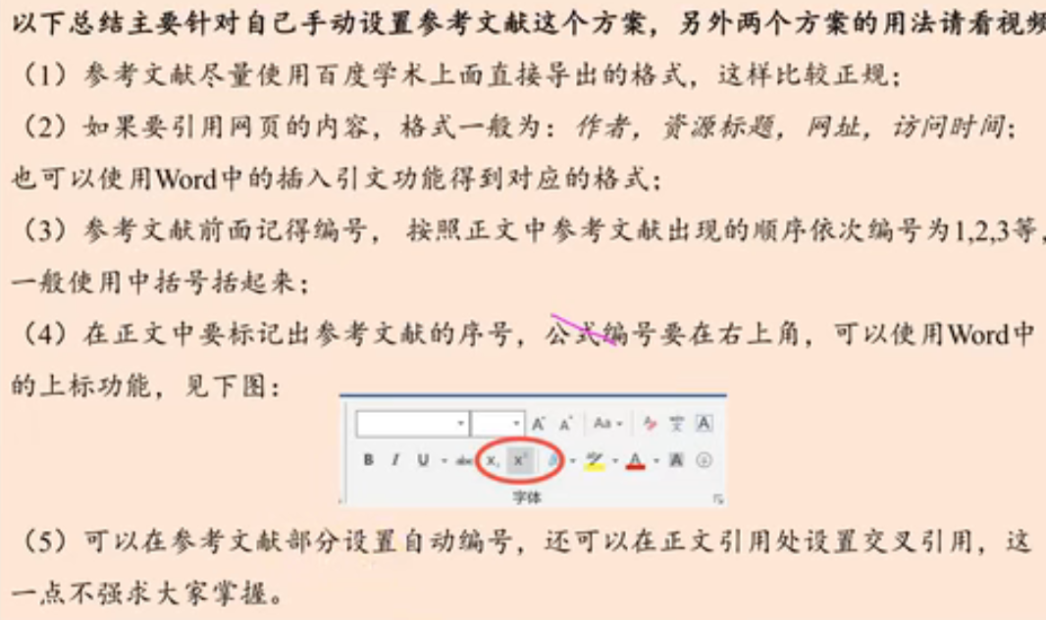

# Appendices

|  |
| --- |
| Appendix 1 |
| Introduce: 这里放上附录1的介绍 |
|  |

|  |
| --- |
| Appendix 2 |
| Introduce: 这里放上附录2的介绍 |
|  |

本部分是附录部分，美赛对于附录不是特别看重，今年还限制了论文的页数（从第二页开始编号，不能超过25页）。

一般新起一页列出附录。

在不超过页数限制的条件下，附录中可以包括下面内容：

* 你们写的代码；
* 某一问题的详细证明或求解过程；
* 自己在网上找到的数据；
* 比较大的流程图；
* 较繁杂的图表或计算结果。